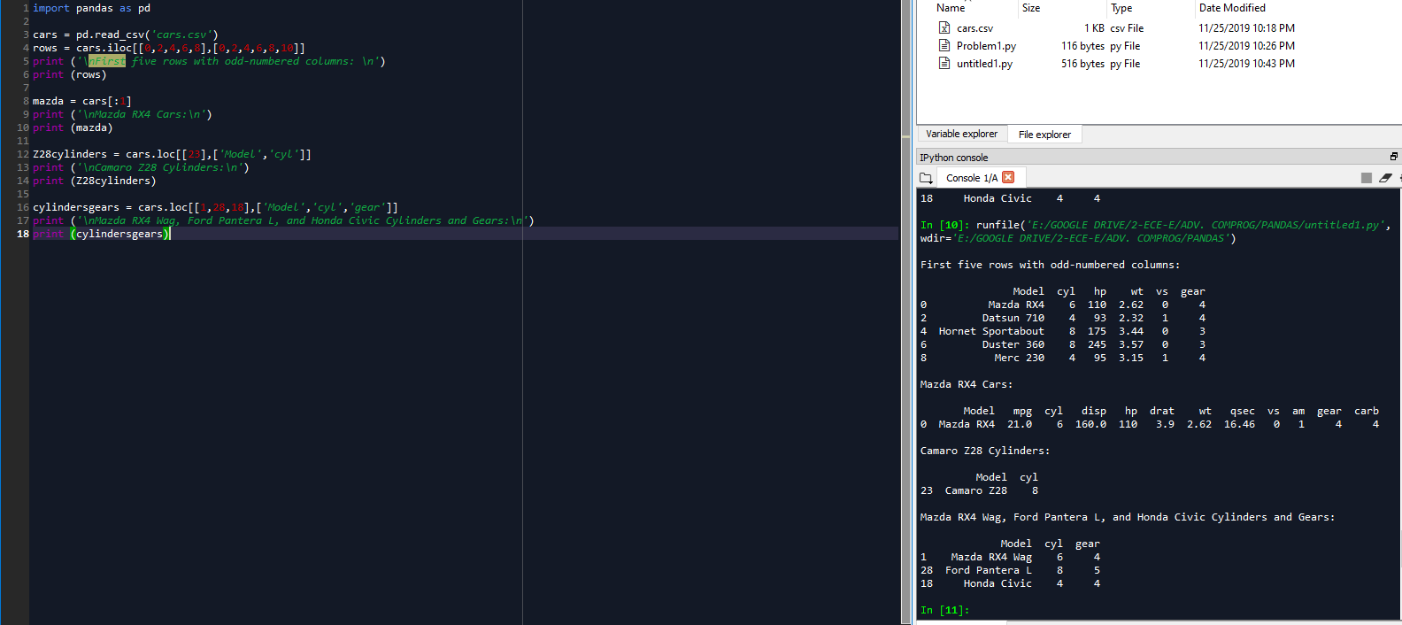PROBLEM 2:

First five rows with odd-numbered columns:

Model cyl hp wt vs gear

0 Mazda RX4 6 110 2.62 0 4

2 Datsun 710 4 93 2.32 1 4

4 Hornet Sportabout 8 175 3.44 0 3

6 Duster 360 8 245 3.57 0 3

8 Merc 230 4 95 3.15 1 4

Mazda RX4 Cars:

Model mpg cyl disp hp drat wt qsec vs am gear carb

0 Mazda RX4 21.0 6 160.0 110 3.9 2.62 16.46 0 1 4 4

Camaro Z28 Cylinders:

Model cyl

23 Camaro Z28 8

Mazda RX4 Wag, Ford Pantera L, and Honda Civic Cylinders and Gears:

Model cyl gear

1 Mazda RX4 Wag 6 4

28 Ford Pantera L 8 5

18 Honda Civic 4 4